Complete Predicate

✅ What Is a Complete Predicate?
# Source: AI Source: Provided by: [Data Path: Persons Table -> ID Column: 1, Name_En Column: Motasem Essam] -> From: [ChatGPT] on [8/4/2025]
A Complete Predicate includes the main verb or verb phrase plus all the words that give more information about the action or state of being — such as objects, modifiers, or complements.

🔸 Key Features:
# Source: AI Source: Provided by: [Data Path: Persons Table -> ID Column: 1, Name_En Column: Motasem Essam] -> From: [ChatGPT] on [8/4/2025]
- It contains the simple predicate (the verb or verb phrase).
- It also includes everything that follows the verb to complete the thought.
- It answers questions like how, what, where, when, to whom, and why.

🔸 Examples:
# Source: AI Source: Provided by: [Data Path: Persons Table -> ID Column: 1, Name_En Column: Motasem Essam] -> From: [ChatGPT] on [8/4/2025]
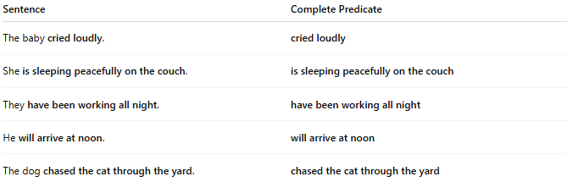
Sentence | Complete Predicate
The baby cried loudly. | cried loudly
She is sleeping peacefully on the couch. | is sleeping peacefully on the couch
They have been working all night. | have been working all night
He will arrive at noon. | will arrive at noon
The dog chased the cat through the yard. | chased the cat through the yard

🔸 Compare with Simple Predicate:
# Source: AI Source: Provided by: [Data Path: Persons Table -> ID Column: 1, Name_En Column: Motasem Essam] -> From: [ChatGPT] on [8/4/2025]

Type | Example Sentence | Predicate
Simple Predicate | The girl sang beautifully. | sang
Complete Predicate | The girl sang beautifully at the recital. | sang beautifully at the recital

